 | Seekonk Black Goose  Fall 2022 Tryouts | 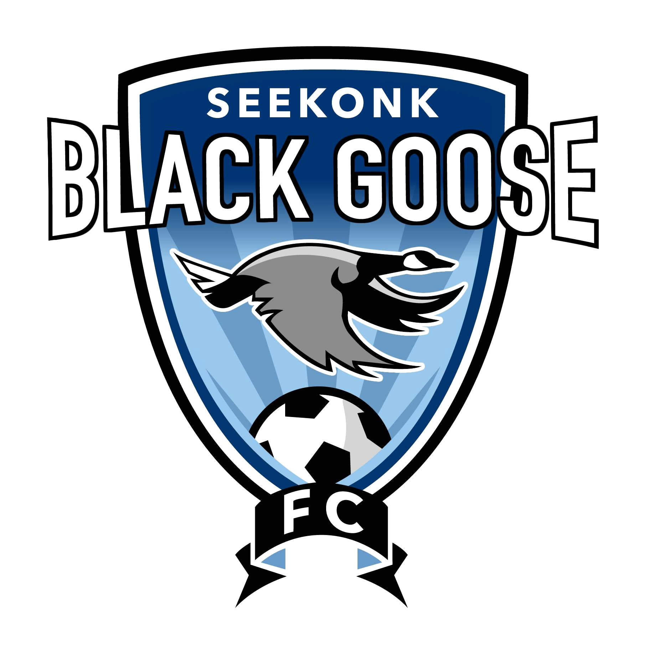
Tryout for the Fall 2022 Season!

.
- Tryouts will be held at the Cole street fields on Wednesday 6/15/22 and Thursday 6/16/22
- Makeup Date for all ages is Wednesday 6/22/22 at 530PM
- Please arrive 15 Minutes prior to tryouts to complete registration at the fields
- Team openings for all Boys and Girls Birth Years 2009-2014. All players in 2014 and younger may try out to play on the 2014 Division.
- All 2008 B.Y. Players and older will be notified by coaches in regards to tryouts
- All current Black Goose players 2009 and younger are required to try out for the Fall
- All players who are assigned a team in the fall will not have to try out again for the spring 2023 season
- Players must wear their current black goose jersey or any jersey with a number on the back.
- All players must have Soccer ball, water, shin guards, and appropriate jersey in order to participate in the tryout.
- The Cost of the 2022 Spring Black Goose is $125.00 plus a $5.00 merchant fee.
- All players will be sent a link to register/pay when they are assigned a team.
- Players will be notified of team placement by 7/1/22

Important Tryout Dates & Details

Boys Tryout Schedule
2013 and younger: 6/15 @ 530-630PM
2011/2012: 6/15@630-730PM
2009/2010: 6/16 @530-630PM
Girls Tryout Schedule
2013 and younger: 6/15 @530-630PM
2011/12: 6/15 @630-730PM
2009/2010@6/16 @530-730PM
www.seekonksoccer.org
*** Follow Seekonk Youth Soccer on Facebook and Instagram ***

