 | Seekonk  Black Goose  Winter/Spring 2023 Tryouts | 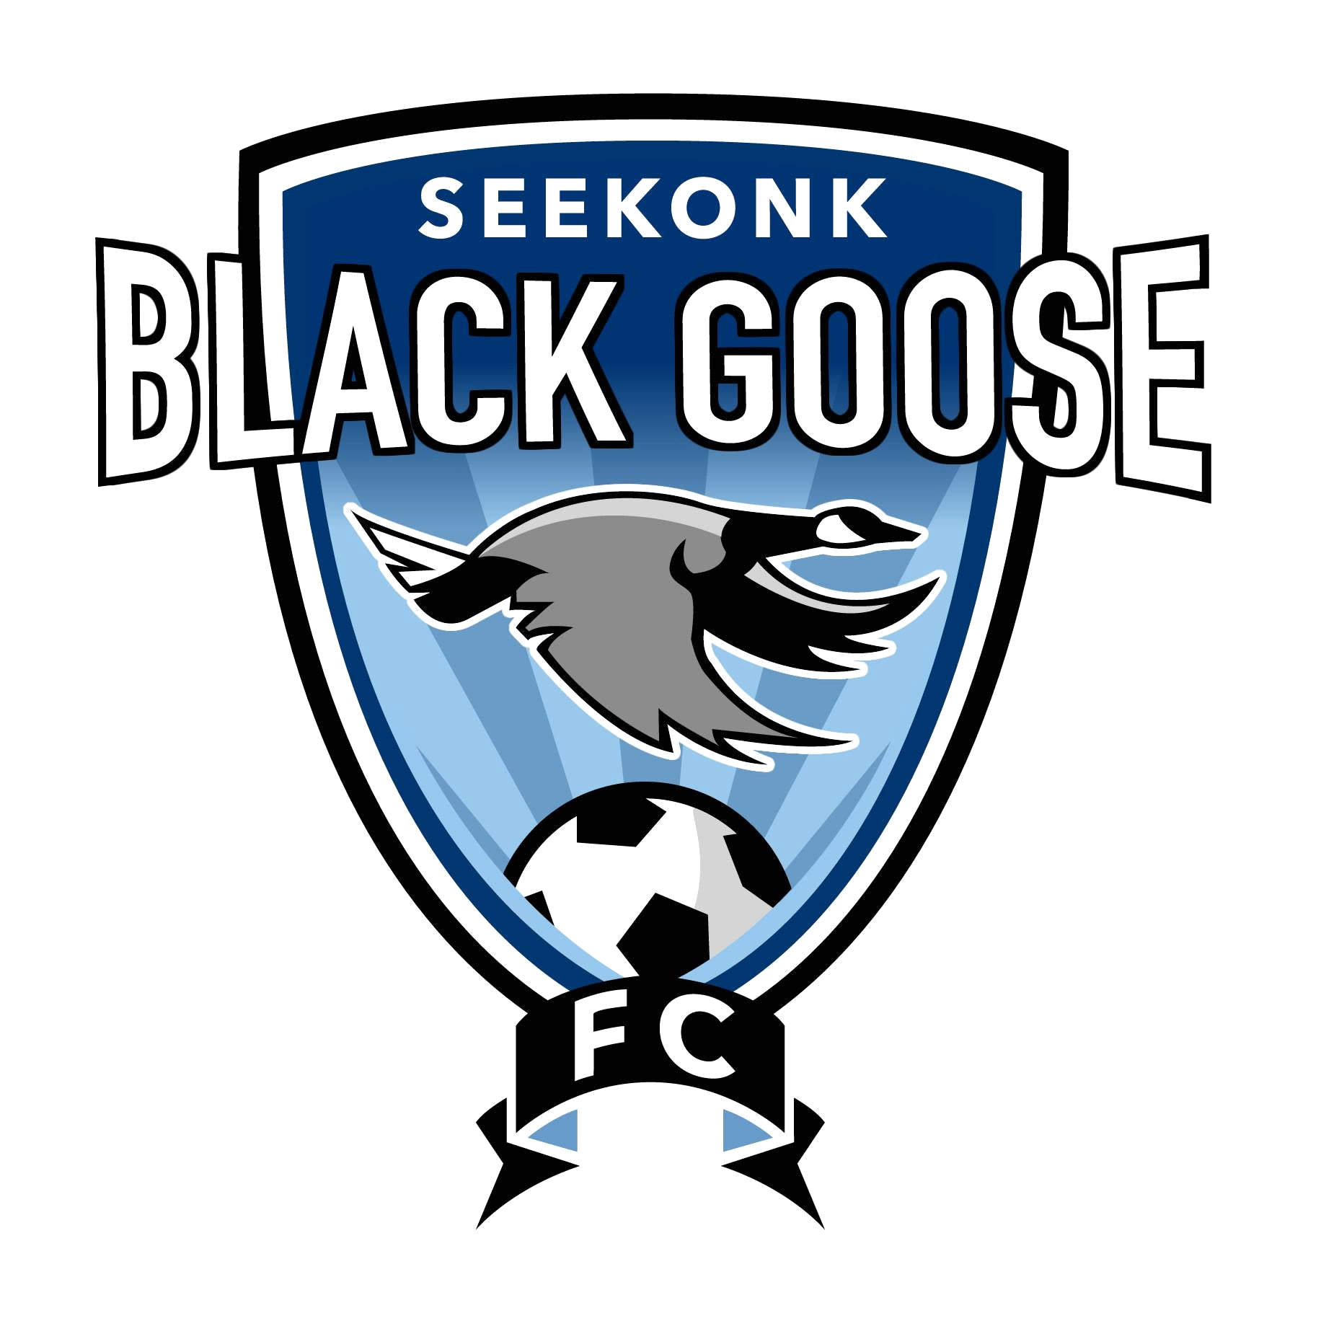
Tryout for the Winter/Spring 2023 Season!

.
- Tryouts will be held at the Cole Street Fields on Sunday 11/6/22 @ 10am for ALL AGES Boys & Girls
- Makeup Date for all ages is TBD
- Registration: Sign Up Genius - Black Goose Tryouts Winter_Spring 2023 or visit SeekonkSoccer.org
- Team openings for all Boys and Girls Birth Years 2009-2014. All players born in 2014 and younger may try out to play in the 2014 Division.
- All players 2008 and older (who did not play Fall 2022) must email president@seekonksoccer.org if interested in Black Goose
- All current Black Goose players 2009 and younger are NOT REQUIRED to try out for the Fall
- Players must wear any jersey with a number on the back.
- All players must have Soccer ball, water, shin guards, and appropriate jersey to participate in tryouts
- The Cost of the 2023 Winter/Spring Black Goose is $155.00 plus a $5.00 merchant fee.
- All players will be sent a link to register/pay when they are assigned a team.
- Players will be notified of team placement by 12/1/22

Important Tryout Dates & Details
Boys Tryout Schedule
2013 and younger: 11/6 @10am-11am
2011/2012: 11/6 @10am-11am
2009/2010: 11/6 @10am-11am
Girls Tryout Schedule
2013 and younger: 11/6 @10am-11am
2011/12: 11/6 @10am-11am
2009/2010: 11/6 @10am-11am
www.seekonksoccer.org
*** Follow Seekonk Youth Soccer on Facebook and Instagram ***

