 | Seekonk  Black Goose  Winter/Spring 2024-25 Tryouts | 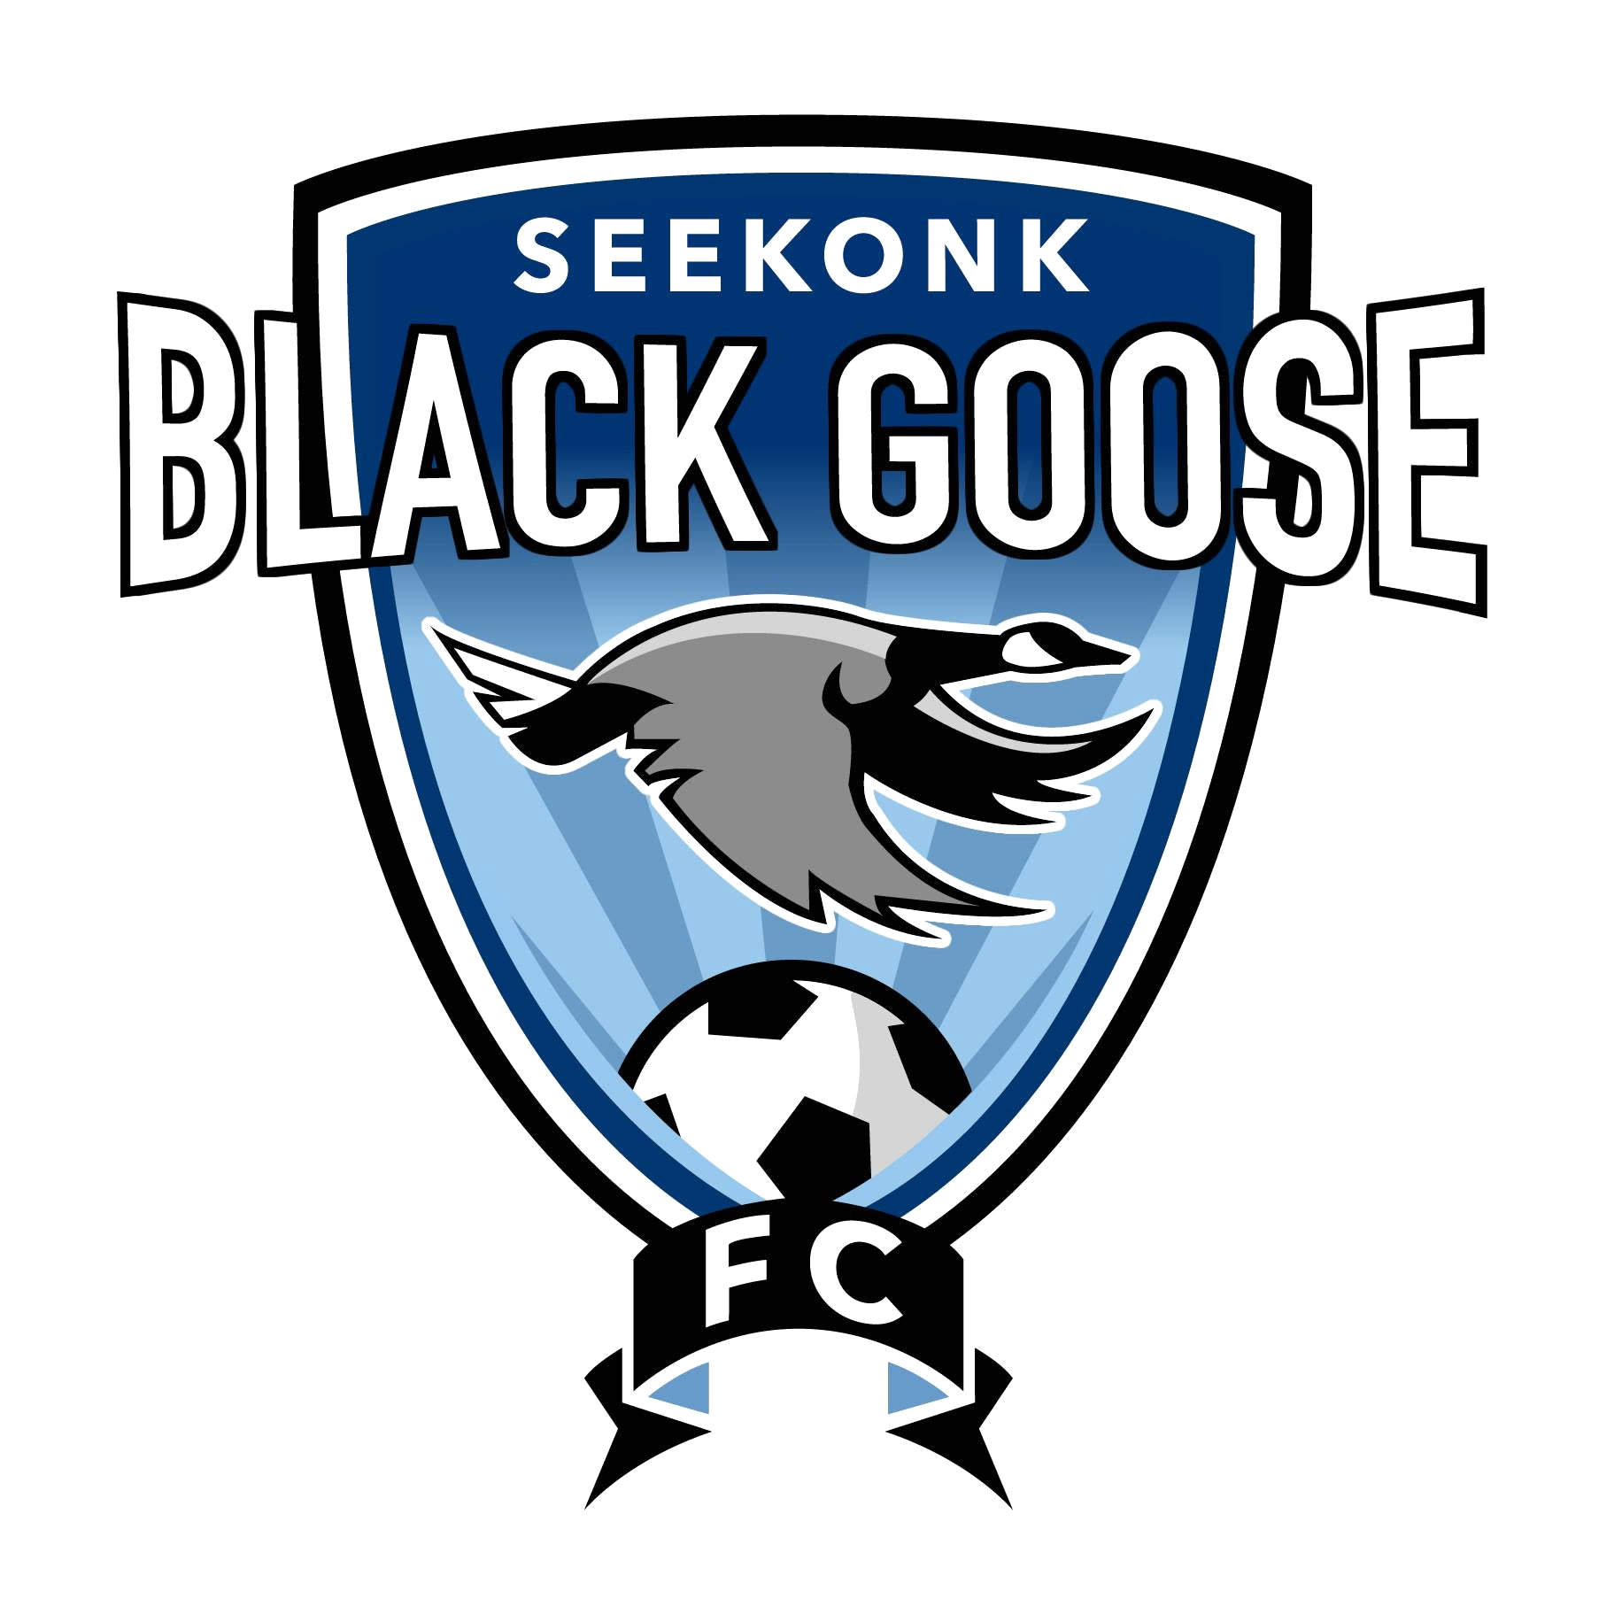
Tryout for the Winter/Spring 2024-25 Season!

- Tryouts will be held at the Cole Street Fields on Saturday 11/2/24 (see times below) conducted by current Black Goose Coaches along with Independent Evaluators.
- Makeup Date for all ages is Sunday 11/3/24 @ 10AM or email blackgoose@seekonksoccer.org
- Registration: https://system.gotsport.com/programs/5379306P6 or visit SeekonkSoccer.org
- Team openings for all Boys and Girls Birth Years 2009-2018.
- All players 2011 and older (who did not play Fall 2024) must email blackgoose@seekonksoccer.org if interested in Black Goose
- All current Black Goose players 2010 to 2014 are NOT REQUIRED to try out for the Winter/Spring
- All current Black Goose players 2015 to 2018 are REQUIRED to try out for the Winter/Spring
- Players must wear any jersey with a number on the back.
- All players must have Soccer ball, water, shin guards, and appropriate jersey to participate in tryouts
- The cost of the 2024-25 Winter/Spring Black Goose is $190.00 plus a $5.00 merchant fee.
- Players will be notified of team placement by 11/25/24.
- All selected players will be sent a link to register if they are assigned a team
- Selected players MUST REGISTER by 12/15/24
Important Tryout Dates & Details
Boys Tryout Schedule
Check in at 9:45am
2014 and Younger: 11/2 @10am-1045am
2012/2013: 11/2 @10am-1045am
2010/2011: 11/2 @10am-1045am
Girls Tryout Schedule
Check in at 8:45am
2014 and Younger: 11/2 @9am-945am
2012/13: 11/2 @9am-945am
2010/2011: 11/2 @9am-945am
www.seekonksoccer.org
*** Follow Seekonk Youth Soccer on Facebook and Instagram ***

